**MR. WAUGAMAN**

**Room 277**

**dwaugaman@alcsny.org**

**716-375-6600 ext 2277**

**EARTH SCIENCE**

**SYLLABUS**

**2023-2024**



**COURSE DESCRIPTION**

**Earth Science is the study of the Earth System and Space. Students taking Earth Science will be introduced to the topics such as, but not limited to: Mapping, Rocks and Minerals, Earthquakes & Plate Tectonics, Geologic Time and Meteorology. The content of this course will be covered in in a variety of formats based on inquiry and hands on learning. There is also a Laboratory component to this course. The aim of this course is to give the student a better understanding and appreciation for the Earth Sciences as well as help each student develop inquiry skills that allow them to think scientifically.**

**STUDENT EXPECTATIONS**

**PRESENCE**

**RESPONSIBILITY**

**HONESTY**

**RESPECT**

***SHOW UP*! you can’t learn when you are not here. Also, be present in *MIND*, don’t day- dream. *PARTICIPATE* in class, & ask questions so you may learn.**

**Your presence will greatly affect your learning and therefore greatly impact your grade.**

***Respect Your Peers*: consider your words and actions carefully – keep them kind.**

***Respect Your Teachers*: I’m here to help you.**

***Respect Yourself*: Don’t settle for less… Only you can push yourself all the way to success.**

**Be on time to class. Be prepared with all materials every day. Complete and turn in your work ON TIME. Own up to your mistakes and FIX THEM. Ask for help when you need it. Act maturely.**

**ALWAYS DO WHAT IS RIGHT!**

***DON’T CHEAT*, it will only *HURT YOU*!**

***DO NOT MAKE EXCUSES*!**

***DO NOT LIE*! Remember if someone cannot trust your word there is nothing else that can be trusted either.**

**Obtaining Course Materials and Microsoft Teams**

**The majority of the course materials (Assignments and Labs) will be handed out on paper during class at the beginning of each week. Teams will be used as a class resource tool. Every Monday a Class Calendar with assignments and due dates will be posted on Teams.**

**All course materials such as Lecture Notes, Help guides, and Study Resources will be uploaded onto our Teams Page under the Class Files Folder. Many of the laboratory exercises will require you to access Teams and download the necessary files for that week’s lab.**

**TEACHING PHILOSOPHY**

**It is my belief that each student should be awarded the same opportunity to succeed as**

**any other student. It is my job to provide each student with the knowledge and resources**

**they need to succeed in this course, and to encourage each student to reach their full potential.**

**However, students will only be successful if they put forth the effort and participate fully in**

**the activities each day.**



[](http://www.google.com/url?sa=i&rct=j&q=&esrc=s&source=images&cd=&cad=rja&uact=8&ved=0CAcQjRxqFQoTCK7QiYSt-8YCFYnQgAodY6UDrg&url=http://www.clipartpanda.com/clipart_images/brain-clip-art-21568722&ei=Wim2Va67I4mhgwTjyo7wCg&psig=AFQjCNERf0vYyaE1HZVvlksyYs-gIt1OAA&ust=1438087892584886)

**COURSE WORK**

|  |  |
| --- | --- |
| **CLASSWORK & ASSIGNMENTS** | Students will be assigned homework regularly. Homework is meant to reinforce the material being learned in class. Homework may consist of practice, finishing unfinished class work, studying class notes, or reading. All homework is due on the assigned date. **If an assignment is not completed by the assigned date a grade of ZERO will be recorded for that assignment *until that assignment is completed*. Any assignment in a topic that is not completed by the day of that topic’s exam will remain a permanent zero.**  **Check Teams Posts and Calendar daily and KNOW WHEN ASSIGNMENTS ARE DUE!** |
| **EXAMS** | Tests and quizzes will be given to assess student’s knowledge of each concept or topic that is studied over no more than a two-week period. If a student pays attention, does their homework and labs; they will have practiced all of the concepts multiple times before the test.  **Be sure to ask questions & Seek Help BEFORE the exam. DO the REVIEWS and STUDY!** |
| **LABORATORY** | **ALL STUDENTS ARE REQUIRED TAKE THE REGENTS EXAM IN JUNE.** New York State mandates that to sit for the Regents Exam each student receive a minimum of 1200 minutes of laboratory activities and submit **satisfactory** reports for each lab exercise that is completed**.** |
| **ATTENDANCE &**  **MAKE-UP WORK** | It is the expectation that students strive for perfect attendance. If a student absent, it is **his or her *responsibility*** to contact the teacher either in person or virtually by Teams Chat or email. ***Makeup work must be completed by the date the teacher assigns.*** |

**GRADING POLICY**

The grading system in this class will be based on a point system. Each item of work will be worth a predetermined number of points. All points will be summed to receive a total number of points possible and earned. Each area of work will then be ***weighted*** accordingly to receive a final percentage. Quarter grades will be determined as follows:

|  |  |
| --- | --- |
| **Quarter Grade Determination** | |
| **Tests & Quizzes**  **Classwork & Assignments**  **Laboratory Exercises** | **50 %**  **30 %**  **20 %** |
|  | |

|  |  |
| --- | --- |
| **Course Grade Determination** | |
| **Quarter 1**  **Quarter 2**  **Quarter 3**  **Quarter 4**  **Regents Exam (Final)** | **20 %**  **20 %**  **20 %**  **20 %**  **20 %** |
|  | |

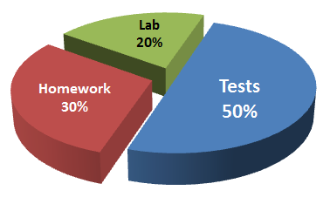

***\*The student and parent(s) will be able to access grades through the Power-School portal at any time throughout the year.*** *Please understand that each day the student grade may change based on that day’s effort by the student. Graded assignments will be updated as quickly as possible, but some assignments or exams may take several days to grade and be recorded in Power-School.*

**CLASSROOM MANAGEMENT**

It is my job, as a teacher, to maintain an environment in which all students can learn safely and comfortably. Therefore, disruptive, inappropriate, and disrespectful behaviors ***WILL NOT*** be tolerated. Should a student fail to meet one of the above expectations, there will be consequences.

**\*Should a first or second offense be deemed severe enough by the teacher, immediate referral to the office will be made.**

***\*The student and parent/ guardian should be familiar will all school policies and guidelines as stated in the student handbook.***

**Warning will be given and I will discuss the issue with the student.**

**1st**

**Teacher Detention Parent or Guardian will be contacted.**

**2nd**

**Discipline Referral to Office. Parent or Guardian will be contacted.**

**3rd**

**COURSE OUTLINE**

**Semester 2**

**Semester 1**

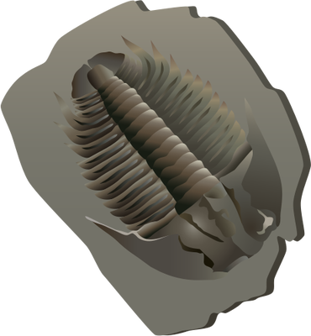

[](http://www.google.com/url?sa=i&rct=j&q=&esrc=s&source=images&cd=&cad=rja&uact=8&ved=0CAcQjRxqFQoTCJ-lovrutccCFUWLDQodLwgD5g&url=http://www.clipartpanda.com/categories/earth-clipart&ei=G9fUVd-rI8WWNq-QjLAO&bvm=bv.99804247,d.eXY&psig=AFQjCNGv_oR5ese8jrwM9flV5UD7b79K9A&ust=1440098453363563)

Interpreting Earth’s History

* The Earth’s History
* Reading the Rock Record

Properties of the Atmosphere

* The atmosphere
* Water in the atmosphere

Weather Systems & Severe Weather

Water Cycle and Climate

Earth in Space

* Studying Space
* The Solar System
* Stars, Galaxies & the Universe

Planet Earth

* Earth as a System
* Models of the Earth

Minerals, Rocks & Resources

* Earth Chemistry
* Minerals & Rocks of the Earth’s Crust
* Resources and Energy

The Dynamic Earth

* Plate Tectonics
* Deformation of the Crust
* Earthquakes
* Volcanoes

Weathering, Erosion, Deposition

* River Systems
* Ground Water
* Glaciers
* Erosion
* Landscapes and Oceans

[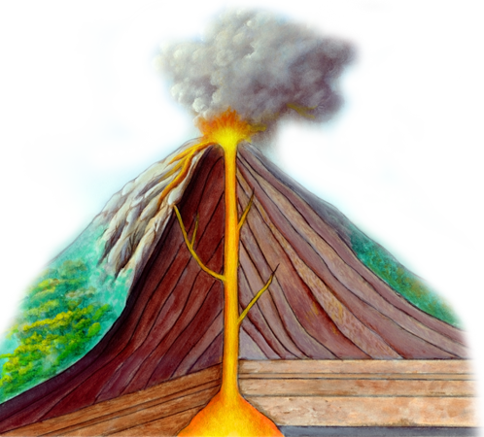](http://www.google.com/url?sa=i&rct=j&q=&esrc=s&source=images&cd=&cad=rja&uact=8&ved=0CAcQjRxqFQoTCM7wwaXvtccCFYjTgAodhIQF0w&url=http://www.sciencefun.org/4th-grade-trivia/&ei=dtfUVc7dEIingwSEiZaYDQ&bvm=bv.99804247,d.eXY&psig=AFQjCNE_Zp2eqBVn_hGxG9BCy9BPut15Rg&ust=1440098527667684)

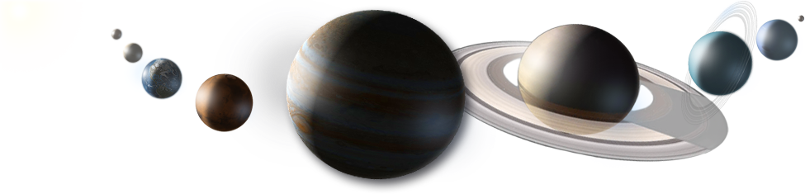

**Mr. Waugaman**

**EARTH SCIENCE**

**PARENT CONTACT INFORMATION**

**2023-2024**

**As a teacher of your child, I will strive to give them the best possible learning environment in my classroom. I welcome regular communication with parents about the progress of their child in Earth Science. To make this more efficient please complete the following information below. All information will be confidential and used only by Mr. Waugaman to maintain communication with you throughout the year. *Please Print Clearly.***

**Student Name: _________________________________**

**Parent/Guardian Name(s): _____________________________________**

**Parent/Guardian Phone Number(s): ________________________ ___________________________**

**Best Time to Contact: _______________________________________**

**Email: _________________________________**

**Any special information I should know about your child:**

**____________________________________________________________________________________________________________________________________________________________________________________________________________________________________________________________________________________________________________________________________________________________________________________________________________________________________________________________________________________________________________________________________________________________**

**Thank You,**

**Mr. Waugaman**